Homework 3
Genoa Sullaway

Preliminary Title:
Evaluating Spatial Variance in Calanus marshallae distribution during the 2014-2106 Marine Heatwave in the Eastern Bering Sea

Introduction/Background:
Marine heatwaves (MHW) have become more prevalent as anthropogenic climate change progresses (Frolicher et al. 2018). In the Northeast Pacific Ocean, the most recent MHW (2014-2016) resulted in mass mortalities and marine mammal strandings, species distribution shifts, fishery closures, and social-ecological network shifts (Cheng and Frolicher 2020, Fisher et al. 2021).
Primary and secondary production are tightly linked to oceanographic conditions. In the Eastern Bering Sea (EBS), copepods such as C. marshallae, underpin the structure of the entire ecosystem. As high nutrient prey items, C. marshallae support marine mammals, numerous subsistence fisheries and a billion-dollar Pollock fishery. However, copepod abundance and community composition are heavily regulated by environmental factors. During cold years, large nutritious copepods are abundant into the Fall and are key prey items for age-0 pollock. The abundance of these copepods have been linked to pollock recruitment through the Oscillating Control Hypothesis (Kimmel et al. 2018). However, during warm years the zooplankton community is dominated by smaller species with lower lipid content (Kimmel et al 2018). This disruption in lipid-rich prey during warm years has negative effects that cascade throughout the EBS food webs and social-ecological networks.
Large scale climate events can lead to increases in spatial synchrony across increasingly large distances (Hanson et al. 2020). MHW’s may increase synchrony in C. marshallae abundance across the EBS, and this can have cascading negative effects through the ecosystem. Moreover, changes to spatial variability in C. marshallae within warm years can have implications for future predator-prey overlap (Siddon et al 2013). This research aims to understand the spatial dynamics of C. marshallae within warm years, and (if time allows) the impact of successive warms years on abundance.

Goals and Objectives
The research question I would like to address is: Is there spatial variation in Calanus abundance during the 2014-2016 Marine Heatwave in the Eastern Bering Sea?
Warm stanzas and marine heatwaves are predicted to become more common in the EBS. I want to understand the spatial variability for Calanus among warm years, to ultimately inform the spatial availability of Calanus prey for higher trophic levels. Does the EBS become a “food desert” for higher trophic levels or are there certain spatial refuges during warm years?
Generally, copepod abundance and phenology are tightly linked to oceanographic conditions. Thus, I expect variation in temperature to be a strong predictor in C. marshallae CPUE. Specifically, I expect a negative relationship between temperature and C. marshallae. Additionally, I expect an effect of year as the MHW progresses, ie. I expect 2014 to be different than 2016 because of cumulative impacts of warm years. I expect C. marshallae to be more abundant in the northern inner shelves compared to the southern and outer shelves, but mediated by temperature (Kimmel et al 2018).

Data Description
Data were collected by NOAA AFSC ECOFOCI during at-sea oceanographic cruises in the Eastern Bering Sea (Figure 1) and zooplankton data were provided to GS by Dr. Dave Kimmel. These data are part of a larger zooplankton community dataset from the eastern Bering Sea. The response variable is Calanus marshallae catch per unit effort (CPUE) (individuals m^3) for each station (each point in Figure 1) sampled in each year of the recent MHW (2014-2016).
Zooplankton data are collected annually on NOAA oceanographic cruises from April-October, however the spatial and temporal schedule is unbalanced from year to year (Figure 1). Copepods are collected using paired bongo nets (20cm frame, 150um mesh and a 60cm frame, 333 um mesh) on oblique tows. The tow depth varies by station and is not necessarily related to bottom depth. If bottom depth is less than 100m, max tow depth is 5-10m above the bottom. However, if max bottom depth is deeper than 100m the max gear depth can vary depending on the sea state, most tows are not deeper than 300m. The samples are identified to lowest taxonomic level and sorted into different stages (C-1 to C-6), however for this analysis I have summed C. marshallae CPUE across lifestages.
Some covariate data is collected onboard the ship, for example maximum bottom depth and gear depth are recorded on the zooplankton gear deployment. Salinity and temperature covariates were collected from CTD casts done in parallel to zooplankton net casts. Covariates such as wind stress and cold pool extent were downloaded from publicly available climate dataset provided by Dr. Mike Litzlow (NOAA AFSC, https://github.com/mikelitzow/bold-new-pollock/tree/master/data).
Exploratory data analysis demonstrate that there is unbalanced sampling of stations across years (Figure 1). Exploratory plots also indicated spatial variability in C. marshallae abundance and the temperature covariate throughout the EBS (Figure 1 and 2). A coplot of select covariates indicate possible relationships between depth, salinity and temperature. We see that there is more variation in temperature and salinity at shallower depths across years (Figure 3). It also appears there is generally less variation in temperature at depth, which is expected based on the differences in water mixing. Interestingly, temperatures at depth is warmer and less variable as the years progress to 2016 (Figure 3).
I will need to test for multicolinearity across covariates, it is likely I do not need all the covariates I propose or that a PCA analysis would help parce down the covariates that are needed. For example, depth, temperature and Ortiz region may be confounded since Ortiz regions were delineated based on oceanographic bounds and shelf breaks that differ by depth and temperature.
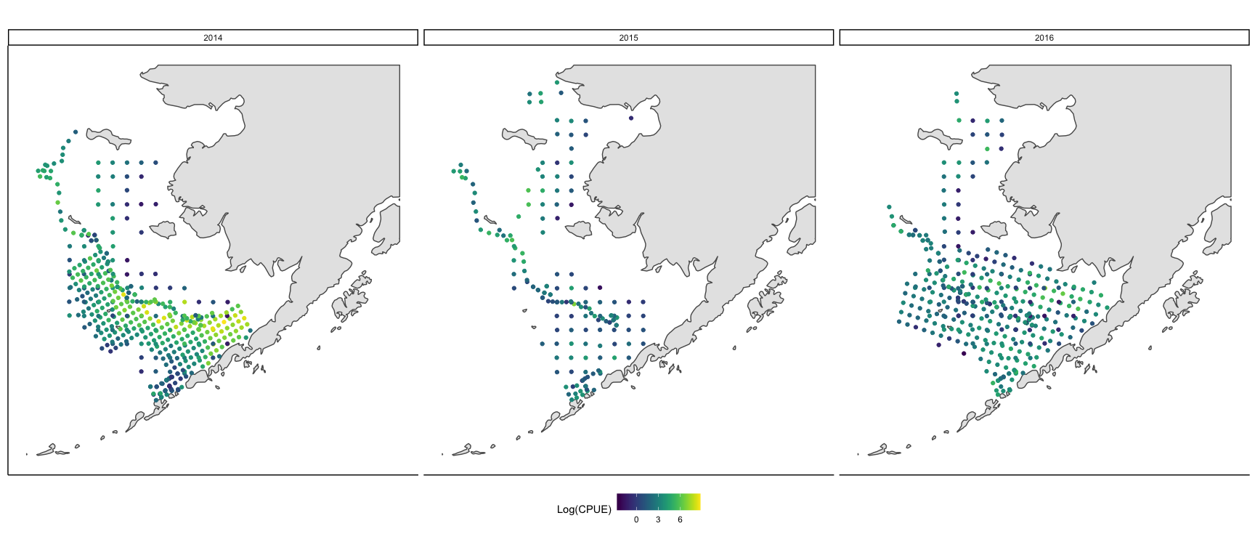
Figure 1. A point indicates a station where a survey was conducted, each facet represents a year, color indicates the log CPUE of Calanus marshallae at each station in each year
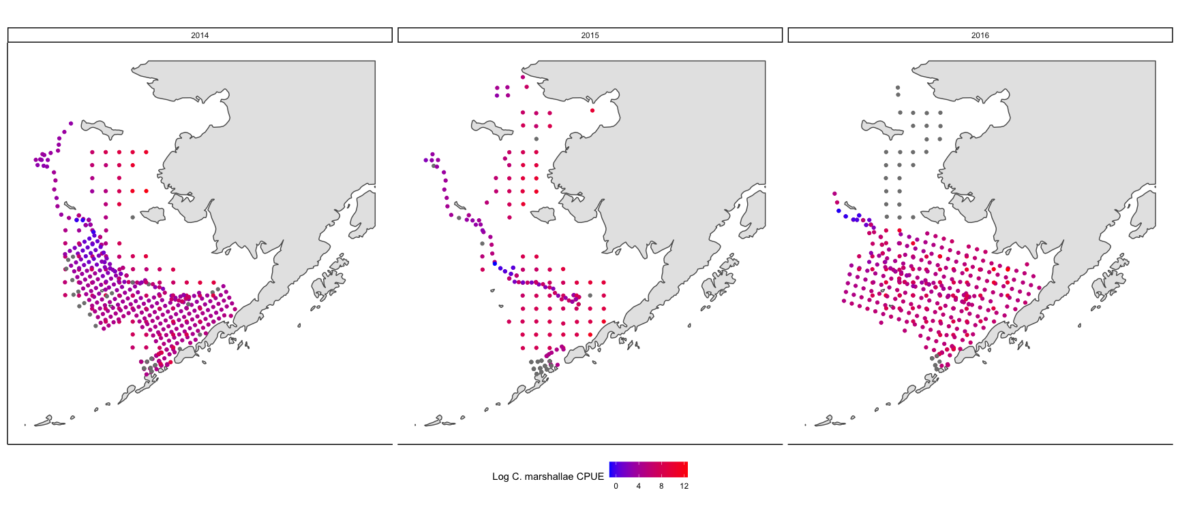
Figure 2. A point indicates a station where a survey was conducted, each facet represents a year, color indicates the mean temperature at each station in each year
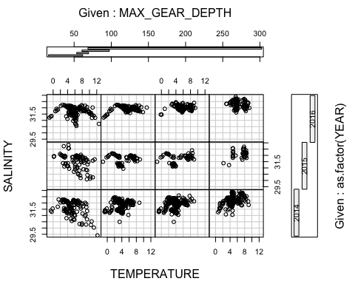
Figure 3. Coplot demonstrating the relationship between temperature, salinity, maximum gear depth and year from stations where zooplankton were surveyed
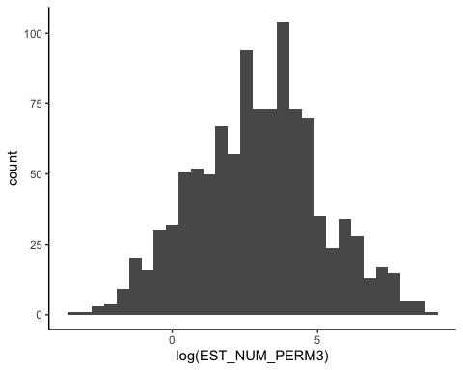
Figure 4. Log-transformed CPUE for the complete Calanus marshallae dataset

Methods
These data may have spatial autocorrelation and they may have a slight right skew. However, with a log transformation (Figure 4) data appear normal, so I propose to use a log normal distribution with a log link for the model. The random variable I would like to estimate is C. marshallae CPUE where $γ_{i}$ = Calanus m-3
$log(γ_{i,s,y})∼LogNormal(μ_{i,s,y},σ^{2})$
$log(μ_{s,y})=B_{0s}+B_{1}Depth_{s,y}+B_{2}Temp_{s,y}+B_{3}SAL_{s,y}+B_{4}Wind_{n,y}+B_{5}CP_{y}+B_{6}Domain_{s}+B_{7}SAL_{s,y}+ε_{s}$
$ε_{s}=MVN(0,σ)$
Where $B_{0i}$ is the random effect of year (note I am interested in looking at temporal autocorrelation, I think the order of the year matters as the heatwave progresses), $Depth_{s,y}$ is the survey depth, $Temp_{s,y}$ is the mean temperature at each station for each year, $SAL_{s,y}$ is the mean salinity at each station for each year, $Wind_{n,y}$ is the wind stress for each direction (north or south) for each year, $CP_{y}$ is the cold pool extent for that year, $Domain_{s}$ is the station domain related to the Ortiz regions delineated by oceanographic bounds. The error term, $ε_{i}$, is assumed to be multivariate normally distributed and $σ$ will be composed of a variance-covariance matrix that accounts for spatial autocorrelation.
Back-transformed results will under go a bias correction.

References
- Cheung, W.W.L., T.L. Frölicher (2020) Marine heatwaves exacerbate climate change impacts for fisheries in the northeast Pacific. Sci Rep 10, 6678 https://doi.org/10.1038/s41598-020-63650-z
- Fisher, M.C., S.K. Moore, S.L. Jardine, J.R. Watson, & J.F. Samhouri (2021) Climate shock effects and mediation in fisheries. Proceedings of the National Academy of Sciences 118, no. 2.
- Frölicher, T.L., E.M. Fischer, & N Gruber. (2020) Marine heatwaves under global warming." Nature 560.7718 (2018): 360-364.
- Hansen, B. B., Grøtan, V., Herfindal, I., & Lee, A. M. (2020) The Moran effect revisited: spatial population synchrony under global warming. Ecography, 43(11), 1591-1602.
- Siddon, E.C., T. Kristiansen, F.J. Mueter, K.K. Holsman, R.A. Heintz, and E.V. Farley. (2013) Spatial match-mismatch between juvenile fish and prey provides a mechanism for recruitment variability across contrasting climate conditions in the eastern Bering Sea. PLoS One 8, no. 12 (2013): e84526.

